**Amazon MSK with cross-Region replication for the DR process**

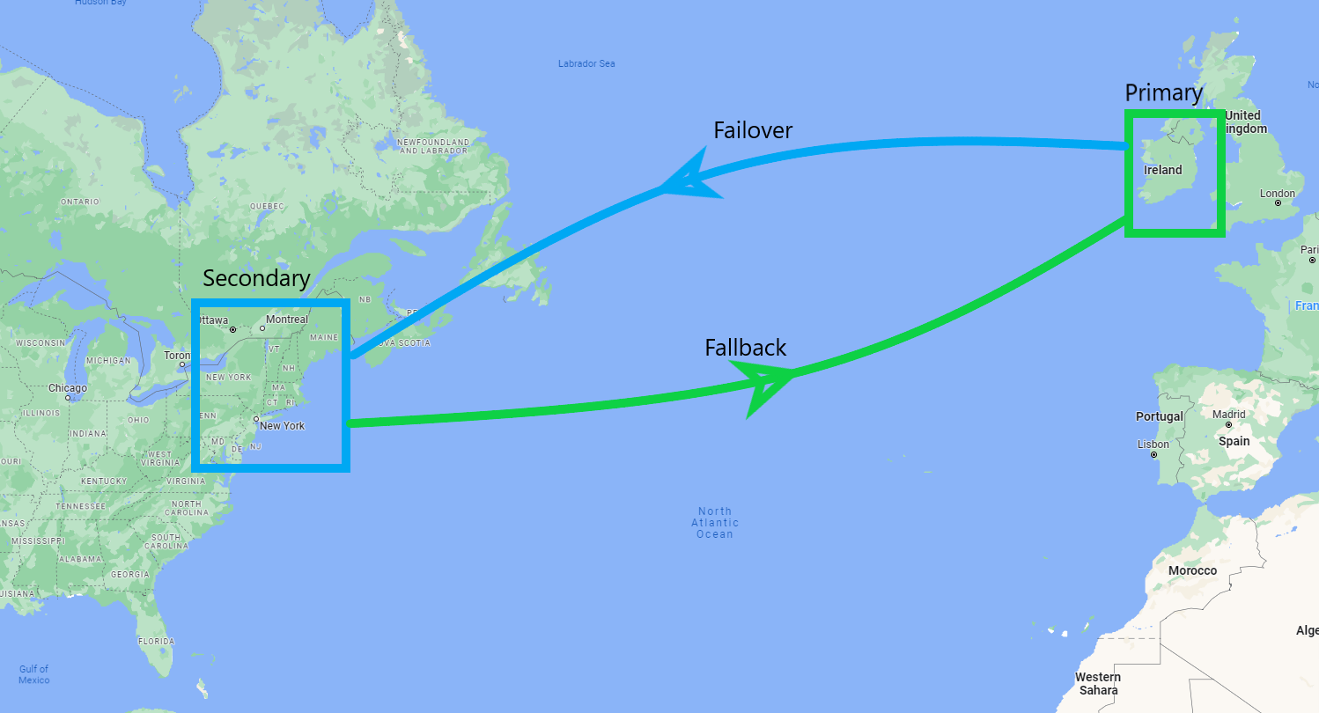

**Solution:  
  
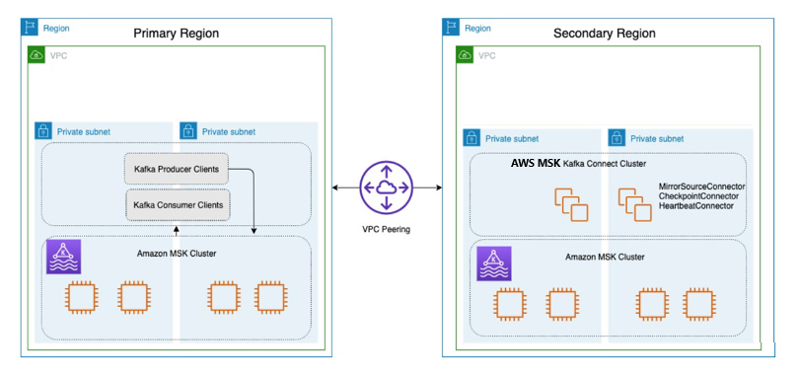**

**MSK connect:  
  
Steps:**

|  |  |
| --- | --- |
| **Steps** | **Terraform scripts** |
| Create MSK cluster in primary region | Terraform plan |
| Create MSK cluster in secondary region | Terraform plan |
| Create VPC peering | Terraform plan |
| Create MSK connect cluster in secondary. This can be reused when we do fallback to primary. | In-progress |
| Within Secondary, Install MM2 with all connectors with both primary and secondary bootstrap servers configured.  This can be reused when we do fallback to primary. |  |
| Test MM2 setup |  |
| Test scenarios cover Active-Active, Active-StandBy |  |
|  |  |

**Failover:**

**Fallback:**